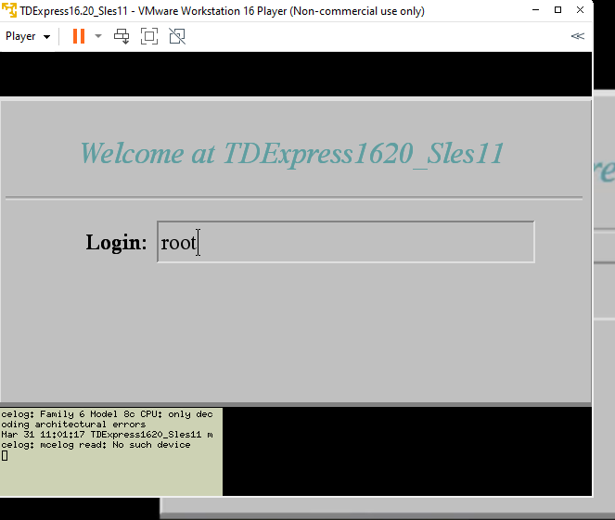

Passowrd : root

Check the db is riunning or not : pdestate -a

If db is donw then run /etc/init.d/tpa start

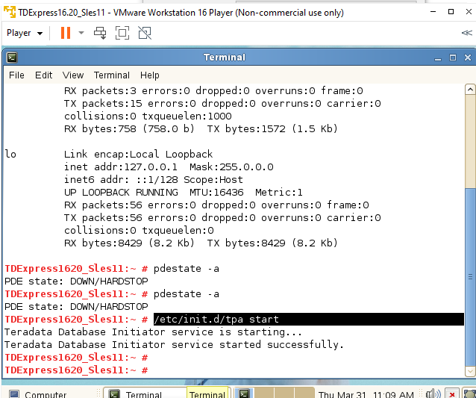

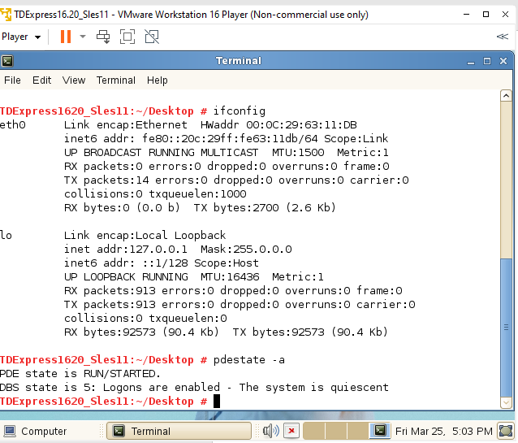

Password dbc

IP 80.20.29.63

92.168.11.128

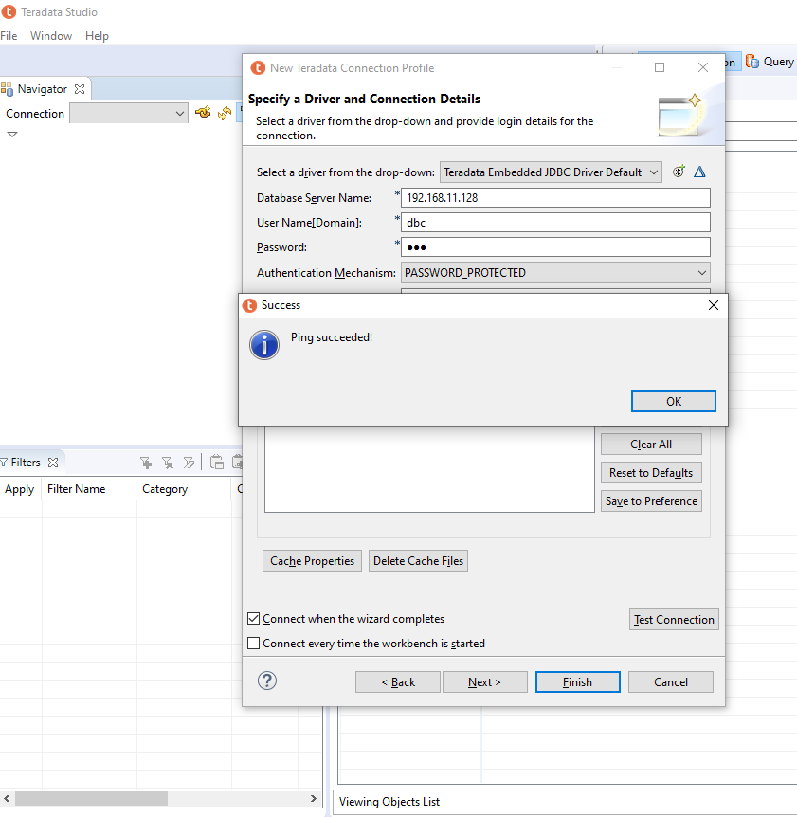

TDExpress1620_Sles11:~/Desktop # ifconfig

eth0 Link encap:Ethernet HWaddr 00:0C:29:63:11:DB

**inet addr:192.168.11.128 Bcast:192.168.11.255** Mask:255.255.255.0

inet6 addr: fe80::20c:29ff:fe63:11db/64 Scope:Link

UP BROADCAST RUNNING MULTICAST MTU:1500 Metric:1

RX packets:3 errors:0 dropped:0 overruns:0 frame:0

TX packets:21 errors:0 dropped:0 overruns:0 carrier:0

collisions:0 txqueuelen:1000

RX bytes:758 (758.0 b) TX bytes:3624 (3.5 Kb)

lo Link encap:Local Loopback

inet addr:127.0.0.1 Mask:255.0.0.0

inet6 addr: ::1/128 Scope:Host

UP LOOPBACK RUNNING MTU:16436 Metric:1

RX packets:6756 errors:0 dropped:0 overruns:0 frame:0

TX packets:6756 errors:0 dropped:0 overruns:0 carrier:0

collisions:0 txqueuelen:0

RX bytes:735053 (717.8 Kb) TX bytes:735053 (717.8 Kb)

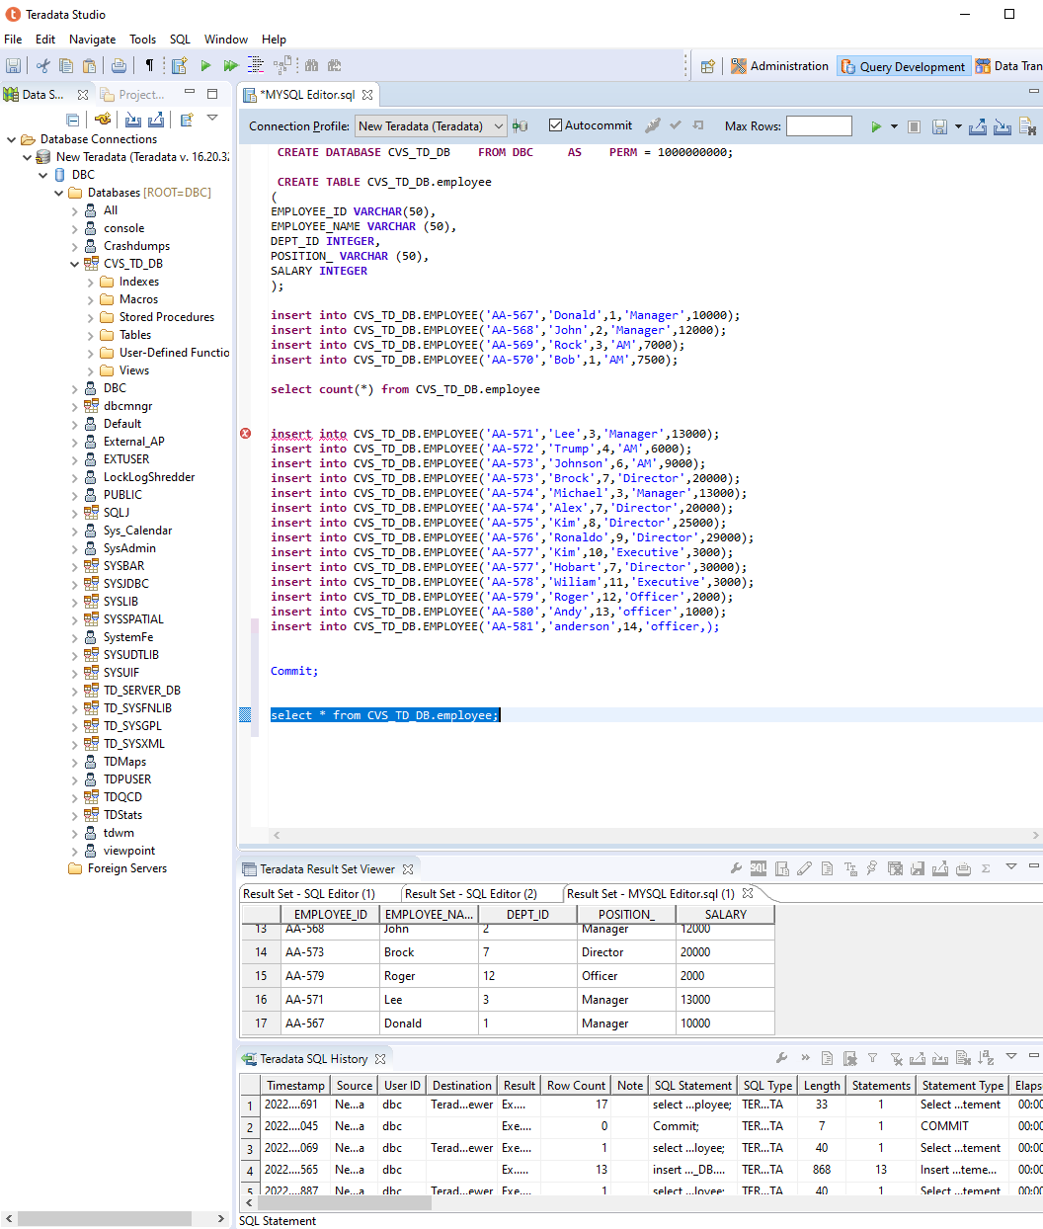

MPP (massively parallel processing)

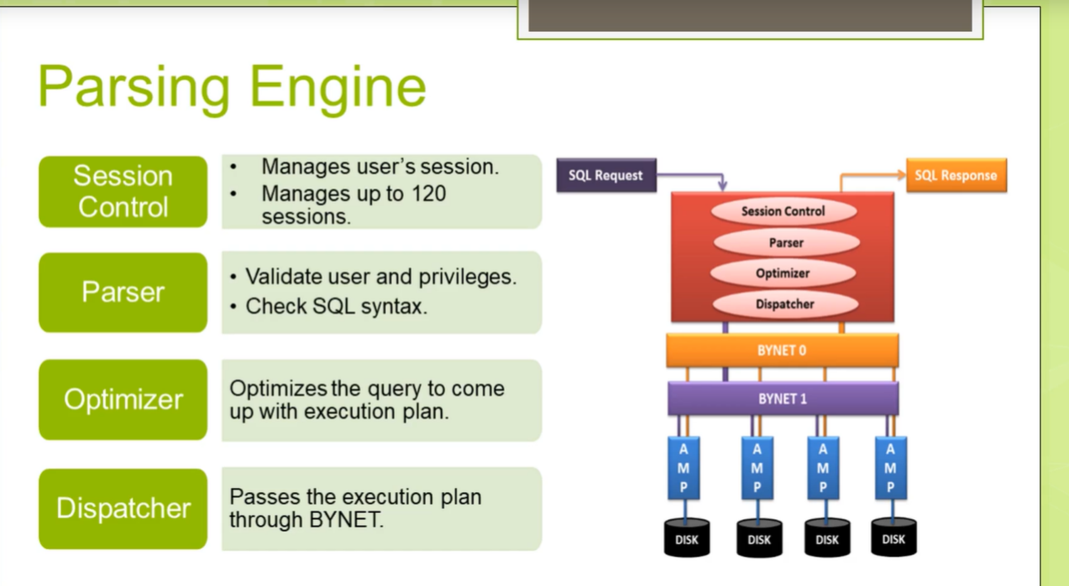

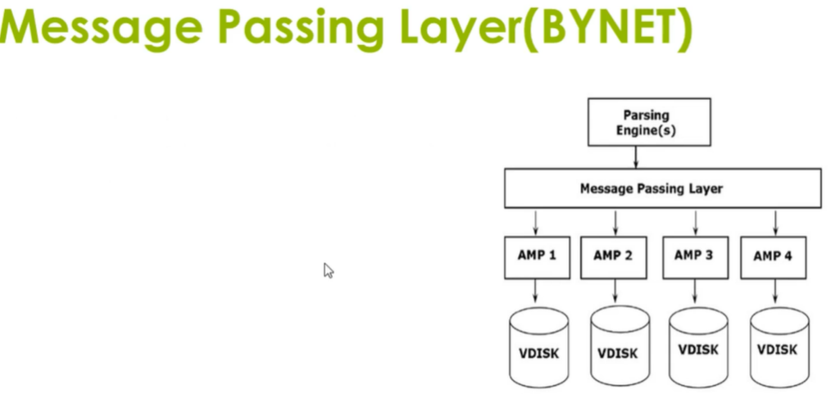

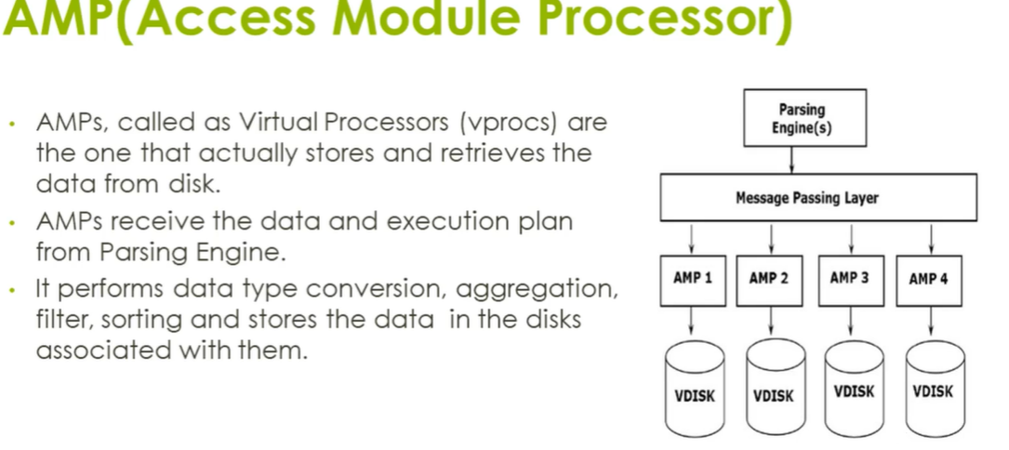

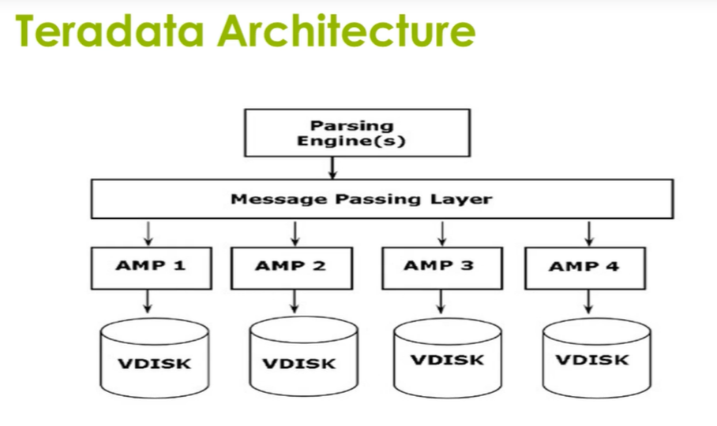

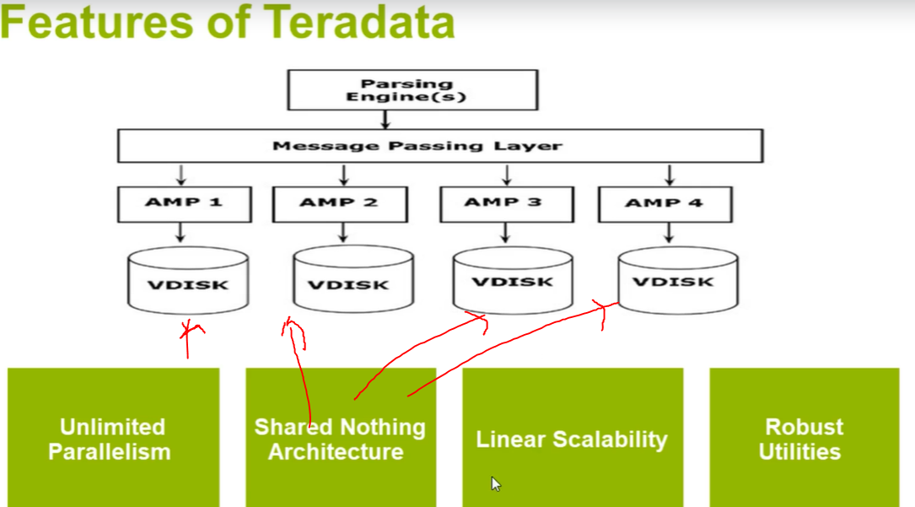

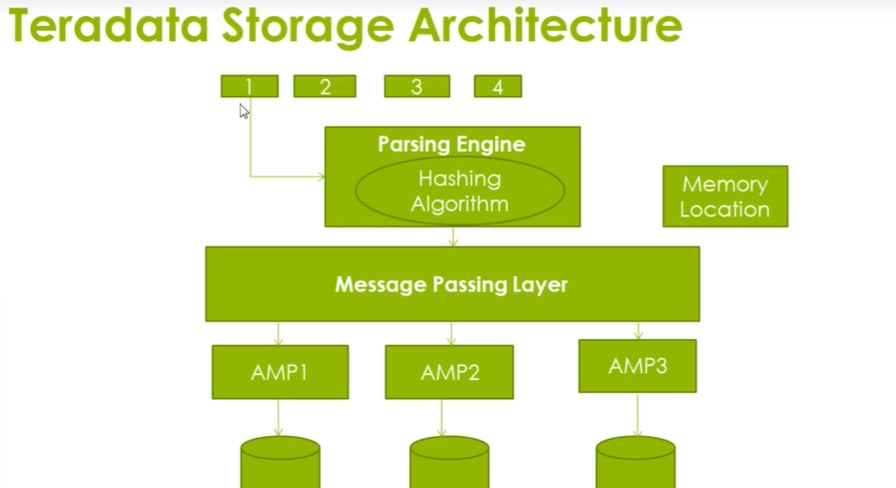

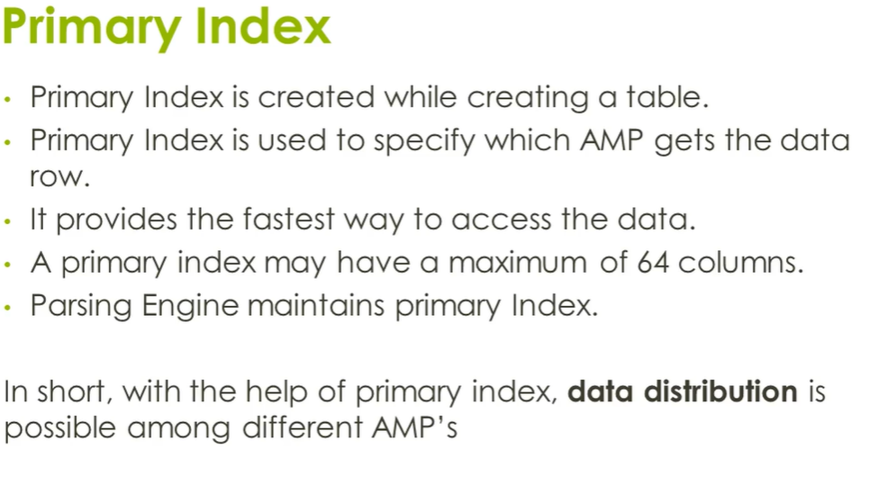

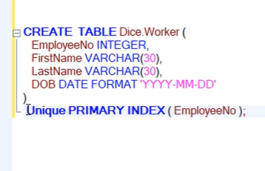

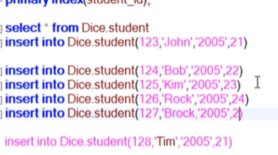

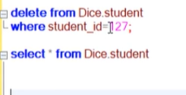

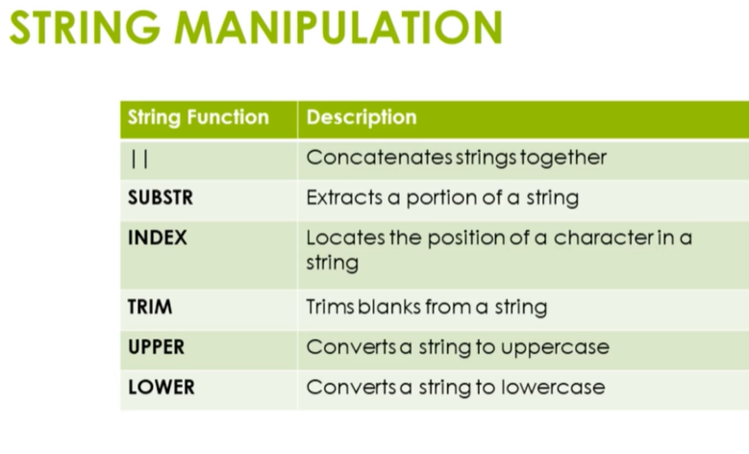

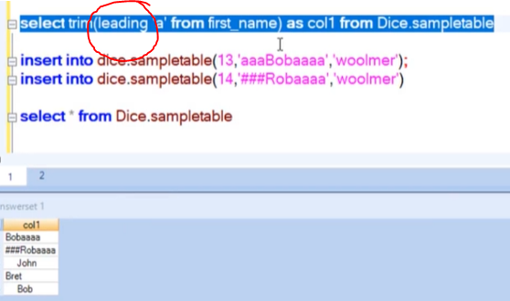

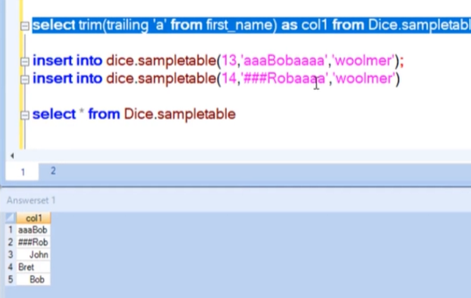

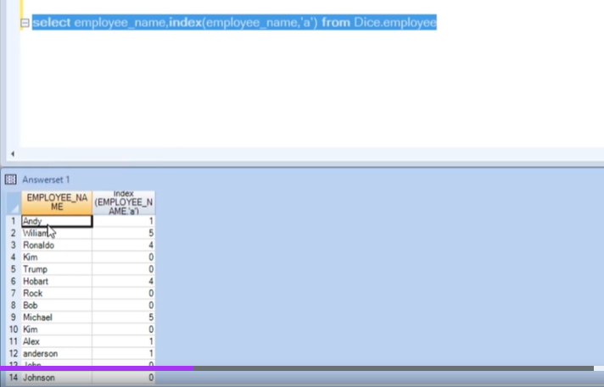

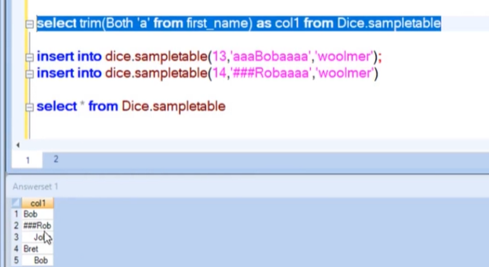

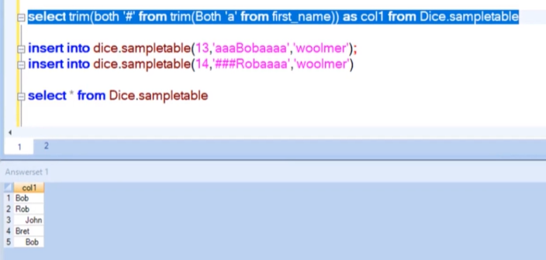

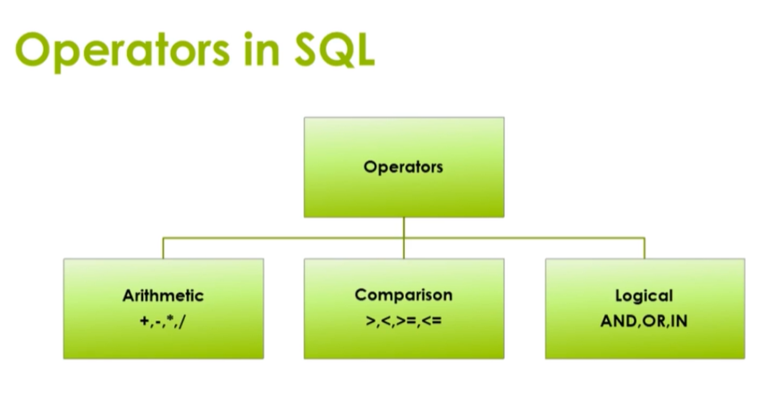

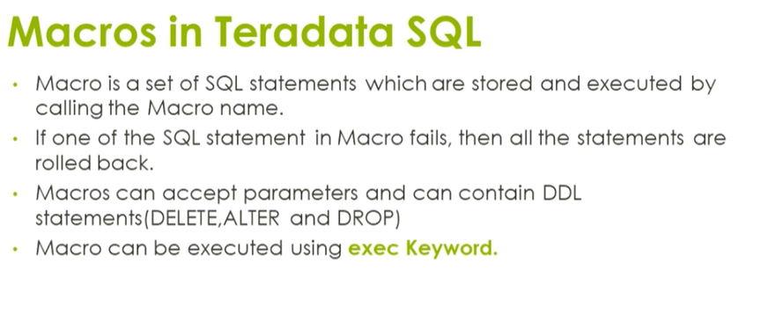

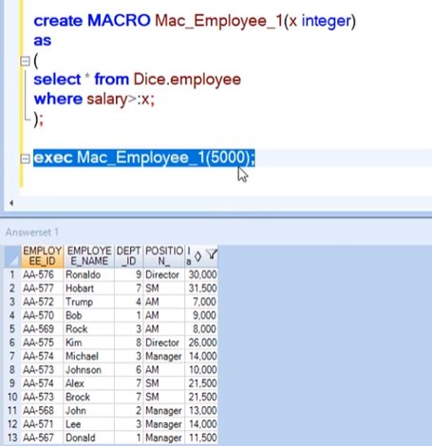

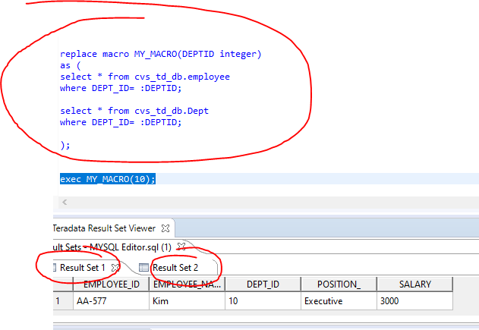

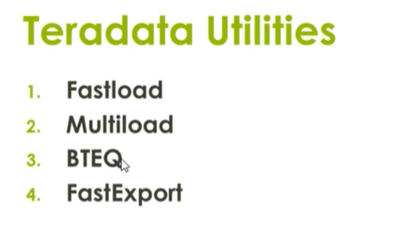

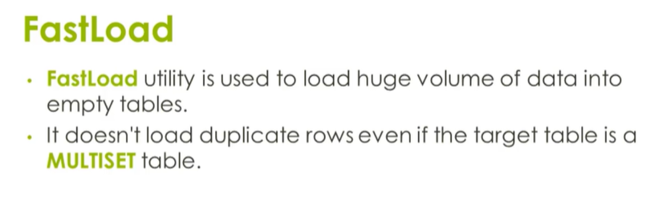

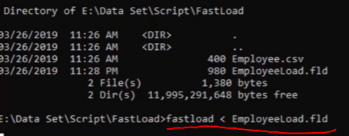

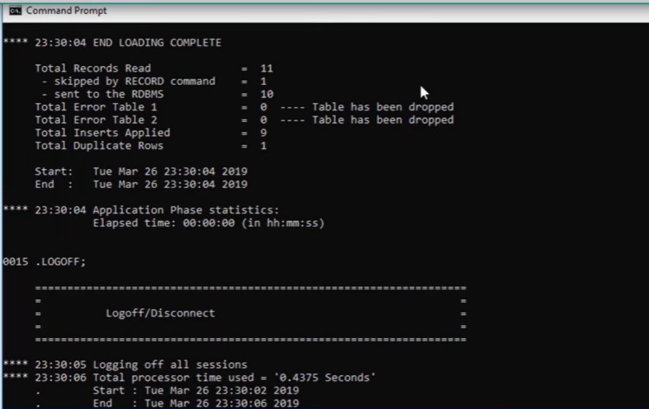

**No duplicate recor will inster**

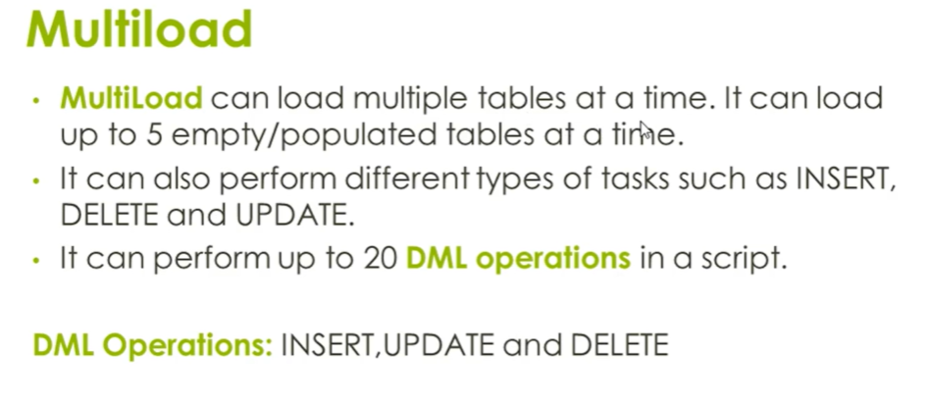

**.ml file**

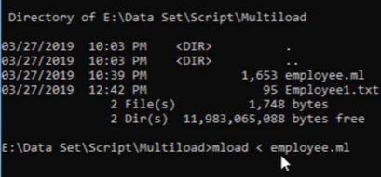

**Basic Teradata Query (BTEQ**)

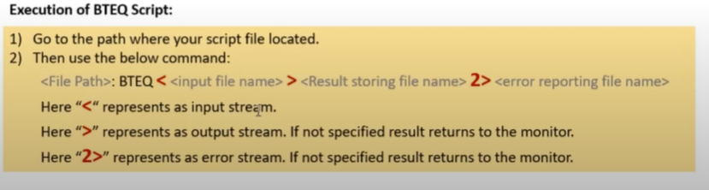

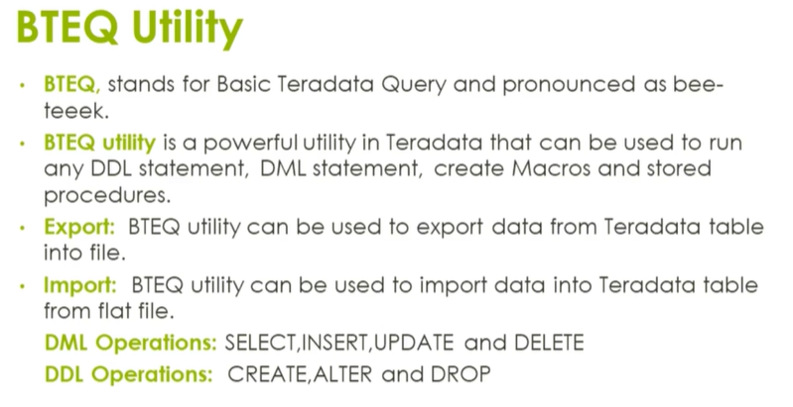

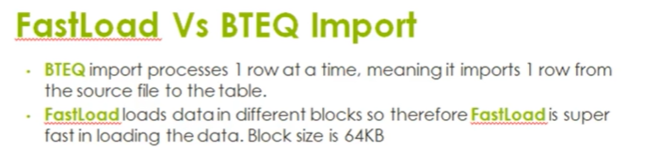

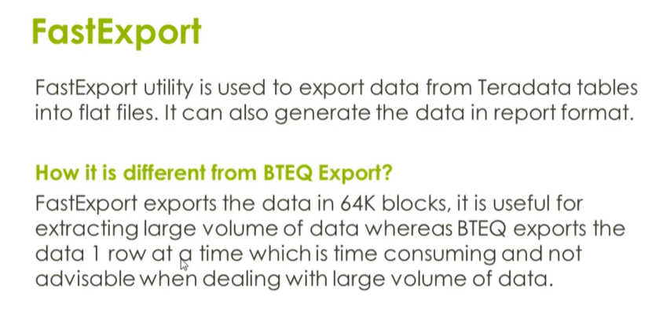

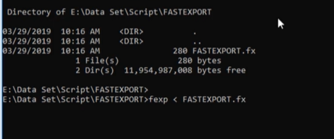

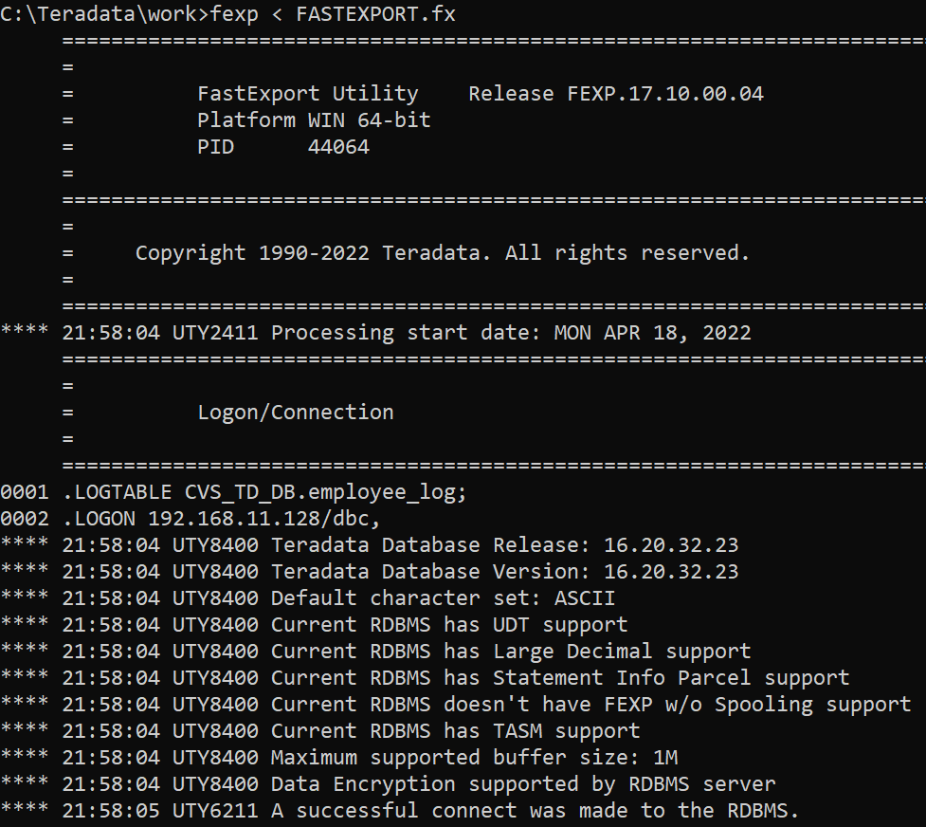

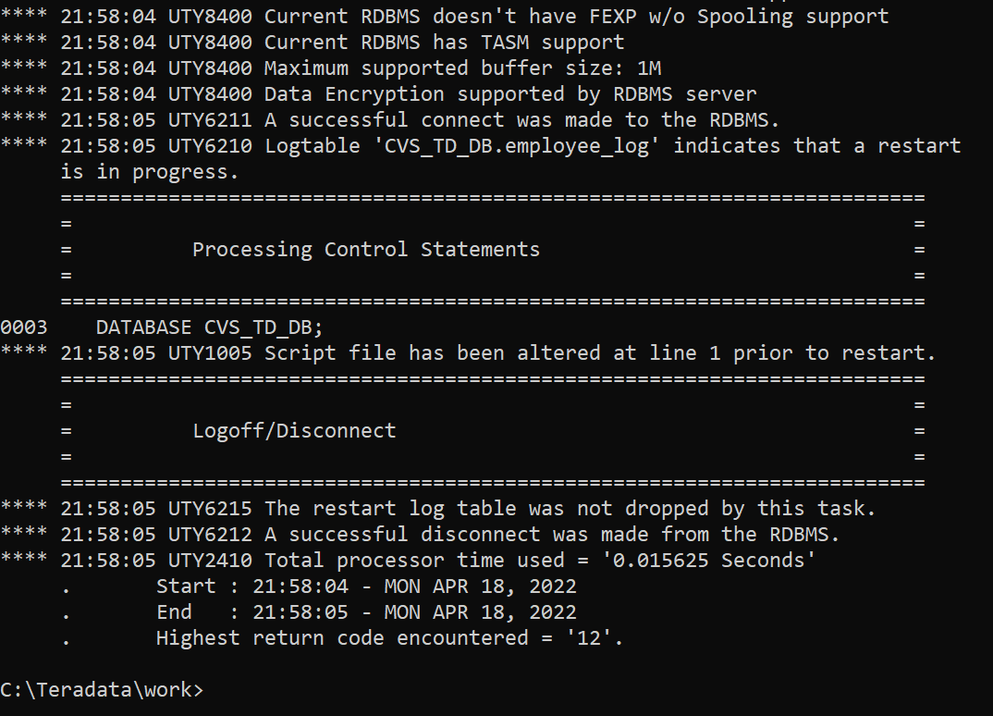

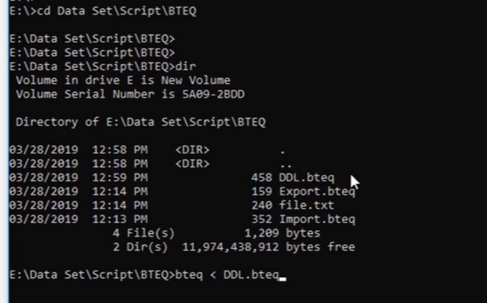

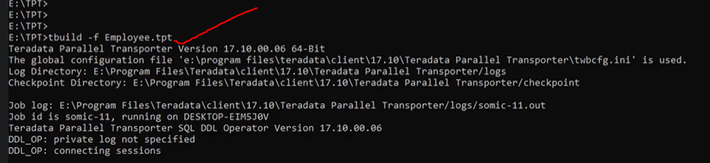

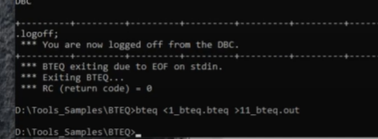

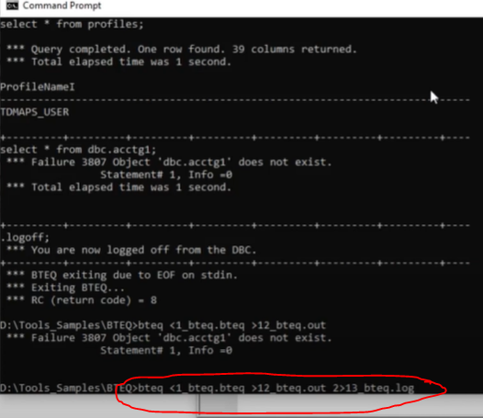

We can store error in another file

FASTLOAD 🡪

C:\Teradata\work>**fastload < EmployeeLoad.fld >fastload.out 2>fastload_err.log**

.sessions 2;

ERRLIMIT 40;

.LOGON **192.168.11.128** /dbc,dbc;

DATABASE CVS_TD_DB;

.set record vartext ",";

17.10 July 2021

<https://docs.teradata.com/r/Teradata-VantageTM-SQL-Fundamentals/July-2021/Introduction-to-SQL-Fundamentals>

my 16.2

<https://docs.teradata.com/r/Teradata-VantageTM-SQL-Fundamentals/March-2019/Introduction-to-SQL-Fundamentals>

Python Teradata

<https://downloads.teradata.com/tools/reference/teradata-python-module>

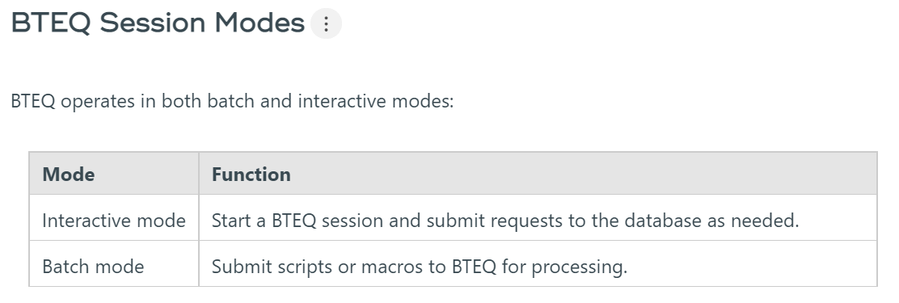

<https://docs.teradata.com/r/Basic-Teradata-Query-Reference/February-2022/Introduction-to-BTEQ/BTEQ-Process/Teradata-Server>

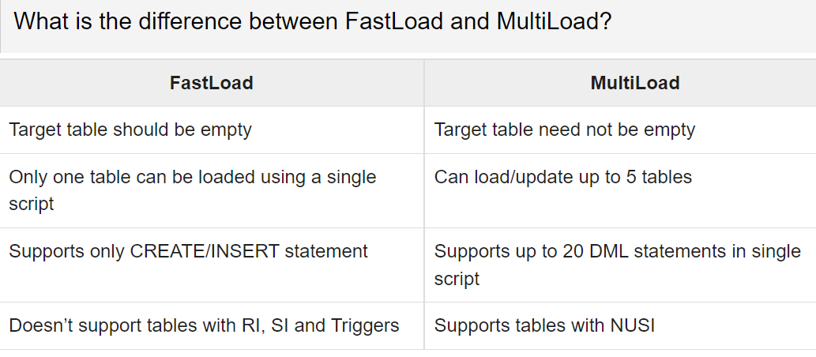

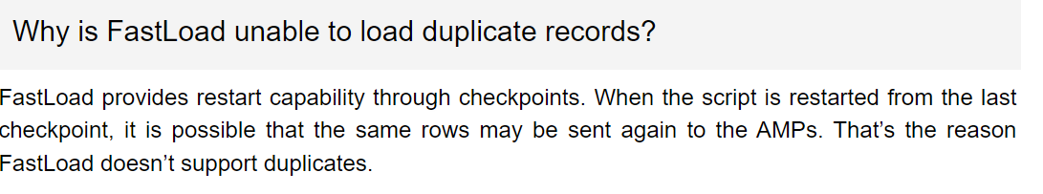

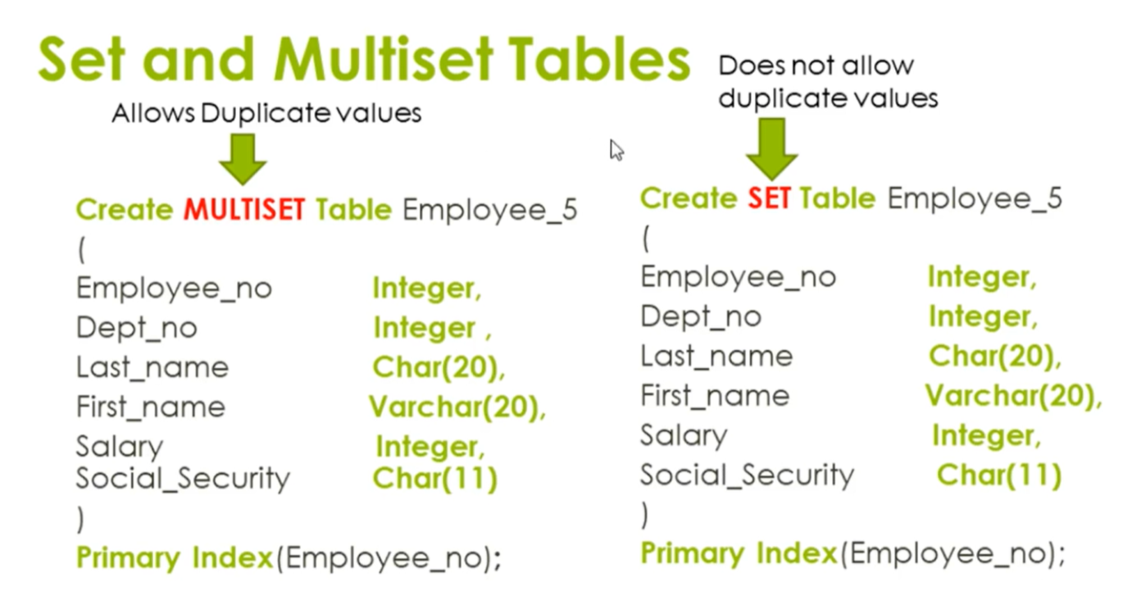

* A **NOPI** is simply a table **without a primary index.**
* It is a feature of Teradata 13.00.
* A **NOPI** table distributes the data randomly, but evenly among different AMPs.
* We insert data into the table based on random distribution. Since, no hashing is involved, data load will be significantly faster.

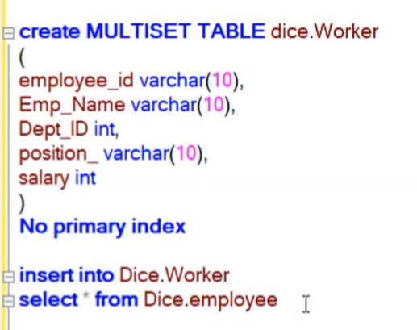

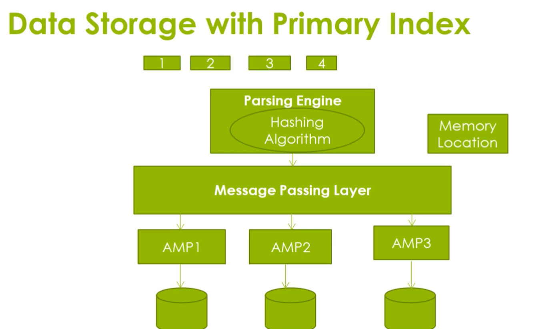

Hashing will slow down data loading but search is good

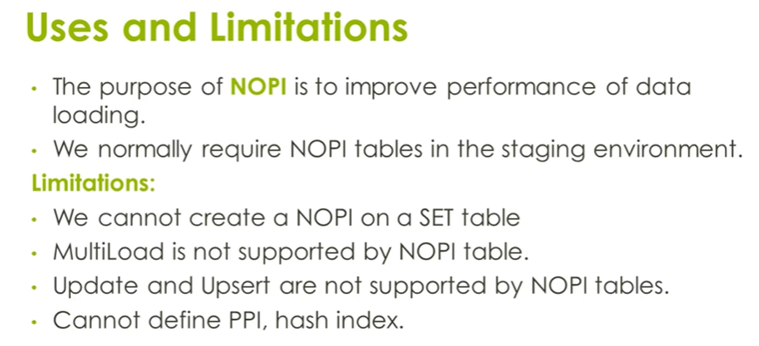

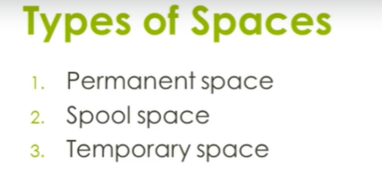

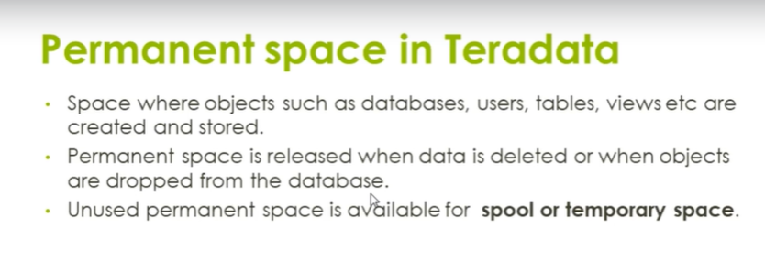

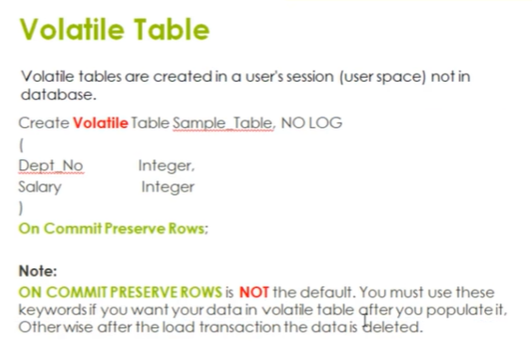

Store in Userspace spool space depend on Session

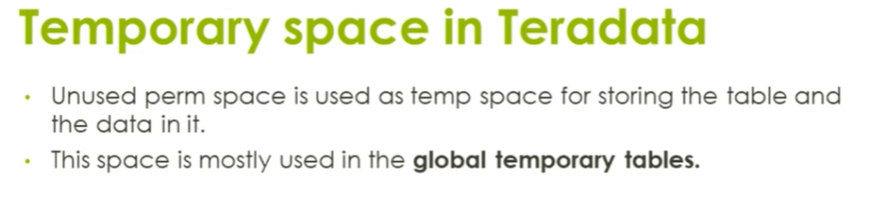

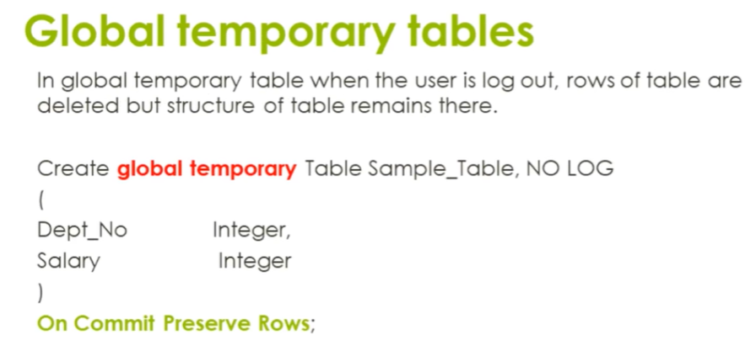

Volatilte table will be deleting after session out but global temp table exists but data delete only after session out .

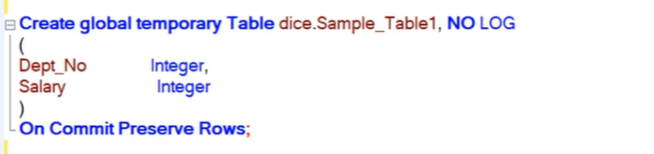

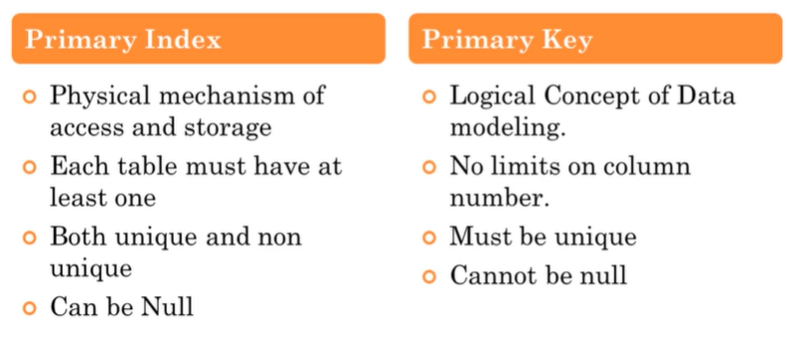

No primary key here ,

Primary index wil create automatically on first column in table

But we can define primary index

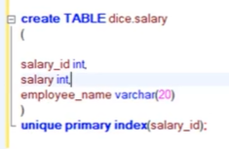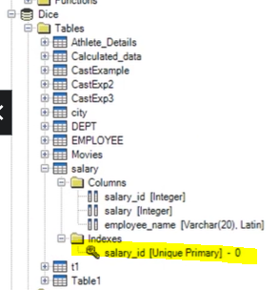

**CREATE** **MULTISET** **VOLATILE** **TABLE** CVS_TD_DB.Temp_employee2 **as**

(**Select** employee_id,employee_name,**d**.dept_id,position_,salary,dept_name

**from** CVS_TD_DB.employee e ,CVS_TD_DB.dept **d**

**where** e.dept_id=**d**.dept_id )

**with** **data** **primary** **index**(employee_id)

**on** **commit** **preserve** **rows**;

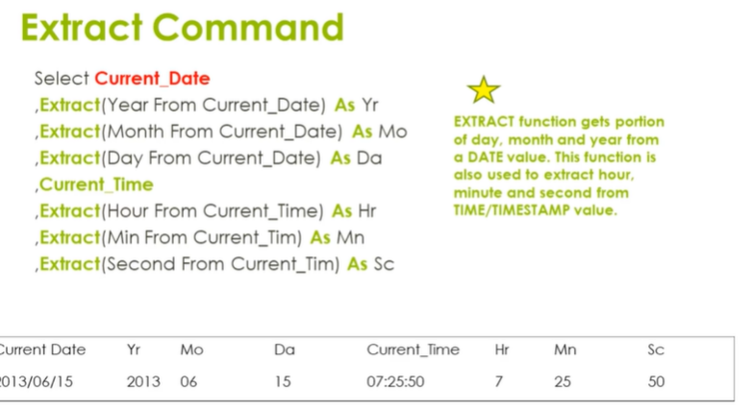

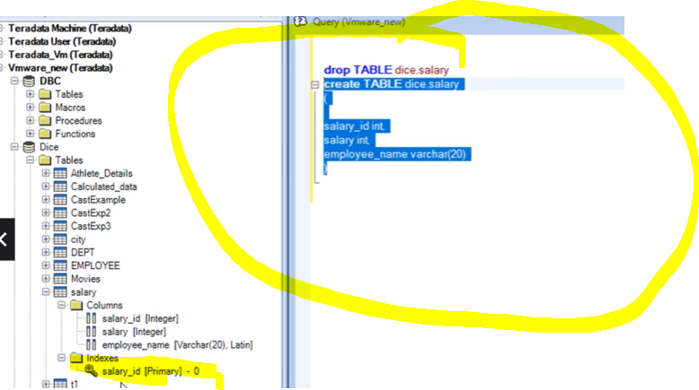

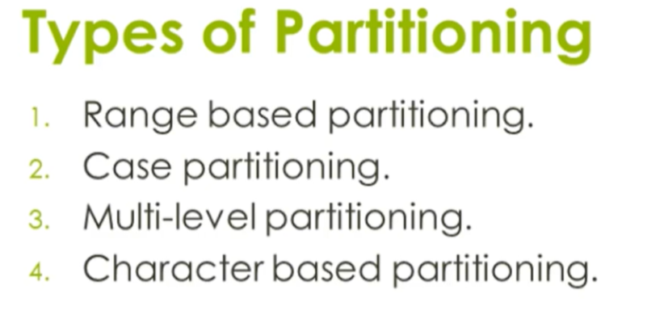

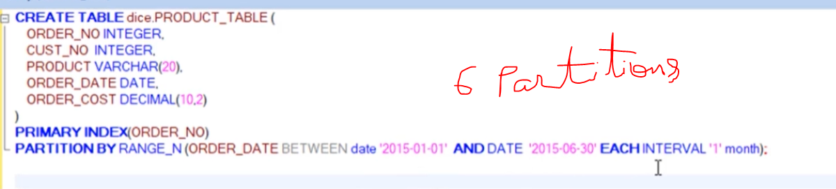

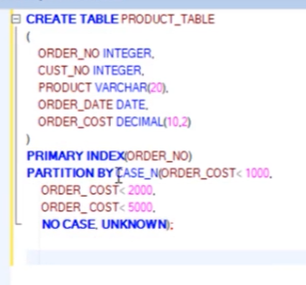

Multi partition level

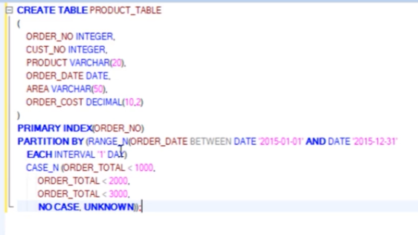

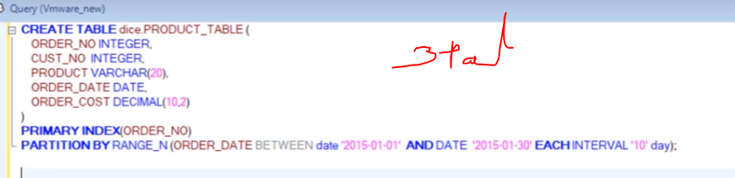

How to identify the number of AMPs in the system?



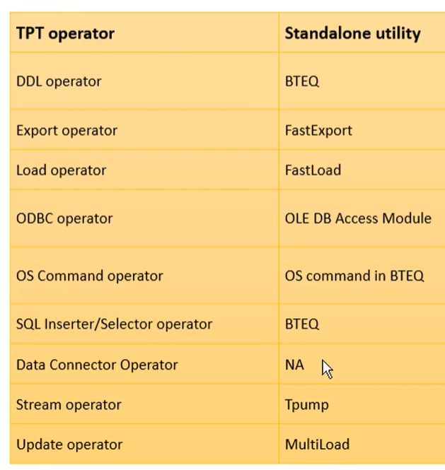

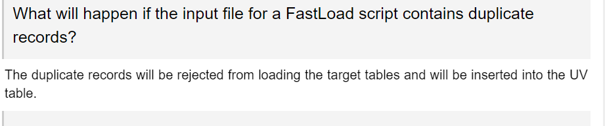

Primary index is defined while creating a table. There are 2 types of Primary Indexes.

* Unique Primary Index(UPI)
* Non Unique Primary Index(NUPI)

Unique Primary Index (UPI)

If the table is defined to be having UPI, then the column deemed as UPI should not have any duplicate values. If any duplicate values are inserted, they will be rejected.

Create Unique Primary Index

The following example creates the Salary table with column EmployeeNo as Unique Primary Index.

CREATE SET TABLE Salary (

EmployeeNo INTEGER,

Gross INTEGER,

Deduction INTEGER,

NetPay INTEGER

)

UNIQUE PRIMARY INDEX(EmployeeNo);

Non Unique Primary Index (NUPI)

If the table is defined to be having NUPI, then the column deemed as UPI can accept duplicate values.

Create Non Unique Primary Index

The following example creates the employee accounts table with column EmployeeNo as Non Unique Primary Index. EmployeeNo is defined as Non Unique Primary Index since an employee can have multiple accounts in the table; one for salary account and another one for reimbursement account.

CREATE SET TABLE Employee _Accounts (

EmployeeNo INTEGER,

employee_bank_account_type BYTEINT.

employee_bank_account_number INTEGER,

employee_bank_name VARCHAR(30),

employee_bank_city VARCHAR(30)

)

PRIMARY INDEX(EmployeeNo);

A table can contain only one primary index. More often, you will come across scenarios where the table contains other columns, using which the data is frequently accessed. Teradata will perform full table scan for those queries. Secondary indexes resolve this issue.

Secondary indexes are an alternate path to access the data. There are some differences between the primary index and the secondary index.

* Secondary index is not involved in data distribution.
* Secondary index values are stored in sub tables. These tables are built in all AMPs.
* Secondary indexes are optional.
* They can be created during table creation or after a table is created.
* They occupy additional space since they build sub-table and they also require maintenance since the sub-tables need to be updated for each new row.

There are two types of secondary indexes −

* Unique Secondary Index (USI)
* Non-Unique Secondary Index (NUSI)

Unique Secondary Index (USI)

A Unique Secondary Index allows only unique values for the columns defined as USI. Accessing the row by USI is a two amp operation.

Create Unique Secondary Index

The following example creates USI on EmployeeNo column of employee table.

CREATE UNIQUE INDEX(EmployeeNo) on employee;

Non Unique Secondary Index (NUSI)

A Non-Unique Secondary Index allows duplicate values for the columns defined as NUSI. Accessing the row by NUSI is all-amp operation.

Create Non Unique Secondary Index

The following example creates NUSI on FirstName column of employee table.

CREATE INDEX(FirstName) on Employee;

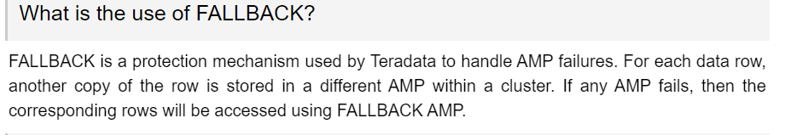

CREATE MULTISET TABLE TARGET_TABLE  
  (  
   columnA INTEGER GENERATED BY DEFAULT AS IDENTITY  
       (START WITH 1  
        INCREMENT BY 20) ,  
   columnB VARCHAR(20) NOT NULL  
  )  
UNIQUE PRIMARY INDEX pidx (ColA);

**Let us say there is a file that consists of 100 records out of which we need to skip the first and the last 20 records. What will the code snippet?**

We need to use BTEQ Utility in order to do this task. Skip 20, as well as Repeat 60 will be used in the script.

Consider a BTEQ script contains the following code in it.

1. .logon 127.0.0.1/user, pass; /* Login credentials */
2. sel top 10 * from dbc.tables; /* Query */
3. .quit

Way 1:  
You can submit the bteq script in batch mode by .RUN FILE command.  
.RUN FILE will execute the commands provided in the file by forward only fashion.  
Example:

1. .RUN FILE = BTEQfile.btq

Way 2:  
You can directly submit the script in the bteq prompt like below.  
Way 1 is being used generally in shell scripts since it is a procedural way.  
Way 2 is used to see the immediate execution of the file supplied.  
Example:

1. Bteq < BTEQfile.btq

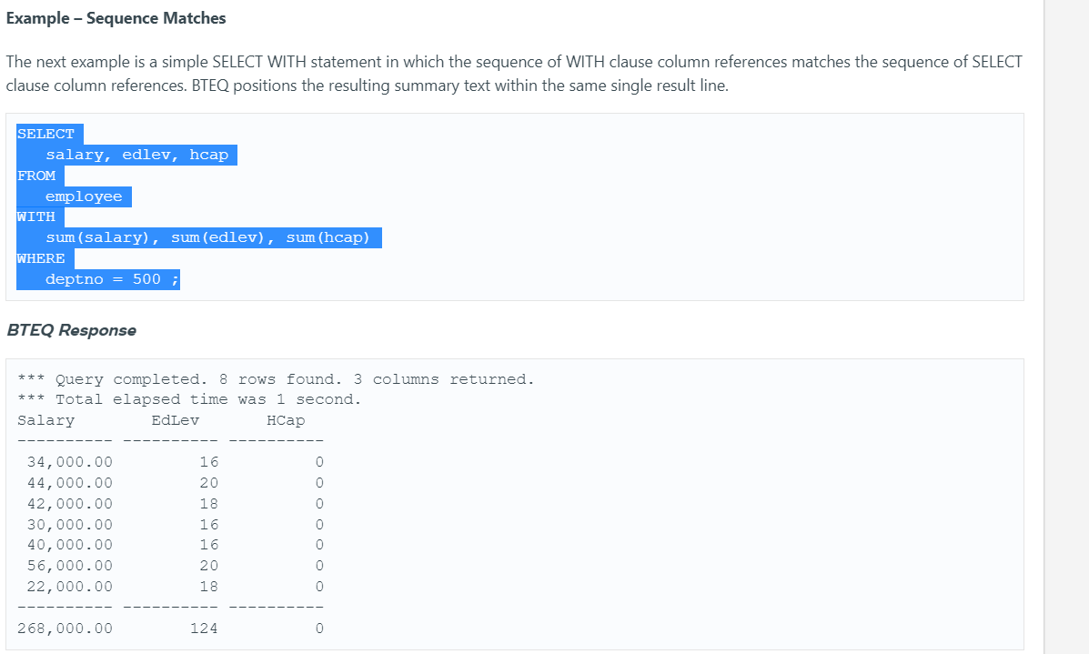

### How to generate row numbers in teradata?

If you have  to use the  row number concept  in target table  as well, then  following  approach using **"identity column"**(from V2R6 onwards )  be used :  
  
CREATE MULTISET TABLE TARGET_TABLE  
  (  
   columnA INTEGER GENERATED BY DEFAULT AS IDENTITY  
       (START WITH 1  
        INCREMENT BY 20) ,  
   columnB VARCHAR(20) NOT NULL  
  )  
UNIQUE PRIMARY INDEX pidx (ColA);  
  
**P.S:**  Identity columns does differ from sequence concept in oracle. The numbers assigned in these columns are not guaranteed to be sequenctial. The Identity column in Teradata is used to guaranteed row-uniqueness.  
  
This  works without use of Identity approach.  
create TABLE TARGET_TABLE as  
(  
   select  
   ROW_NUMBER() over( ORDER BY columnA ) NUMBER_SEQ ,  
   columnA,  
   columnB,  
   columnC  
   from a join b on a.id=b.id  
) with data ;